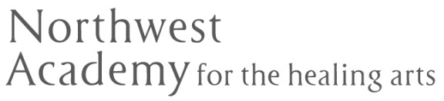
Resume Writing Assignment

After watching the videos and reading the chapters in your textbook on resume writing (Chapter 8), your assignment is to write a 1-2 page functional resume.
This resume should be specific to the massage therapy profession and relevant to the position or specialty at which you will be applying for.
Video Links:
- Rasmussen College Shares the Do's and Don'ts of Resume Building: https://www.youtube.com/watch?v=HhEMnuz40DA
- Biggest Resume Mistakes: https://www.youtube.com/watch?v=NZalKNsr74o

